Lab 9:
Q.1. Write a GPSS program to simulate a barber shop for a day (10 am to 5 pm) where a customer enters the shop every 10±3 minutes and a barber takes 4±2 for a haircut.
Source code:
GENERATE 600,180
SEIZE BARBER
ADVANCE 240,120
RELEASE BARBER
TERMINATE 1
START 25200
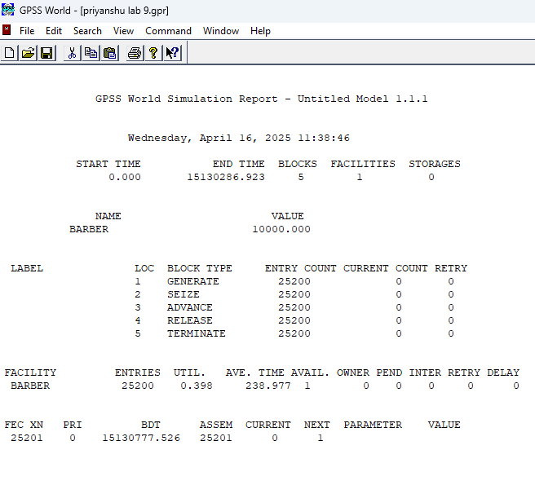
Output:

Q.2. A machine tool in a manufacturing shop is turning out parts at the rate of one every 5 minutes. As they are finished, the parts go to an inspector who takes 4±3 minutes to examine each one and rejects 10% of the parts. Write GPSS program for 1000 parts.
Source Code:
SIMULATE
GENERATE 300
ADVANCE 240,180
TRANSFER .1, REJECTED
TERMINATE 1
REJECTED TERMINATE 0
START 1000
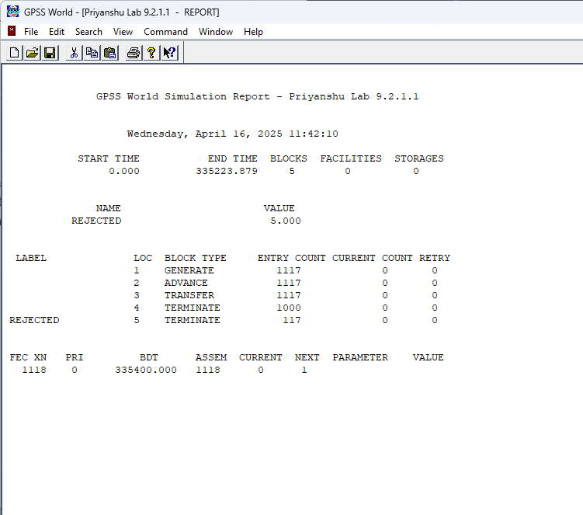
Output:

Q.3. Implement Q. No. 2 using facility.
Source code:
GENERATE 5,,,1000
SEIZE INSPECTOR
ADVANCE 4,3
RELEASE INSPECTOR
TRANSFER .1, REJECT
TERMINATE 1
REJECT TERMINATE 1
INSPECTOR STORAGE 1
START 0

Output:
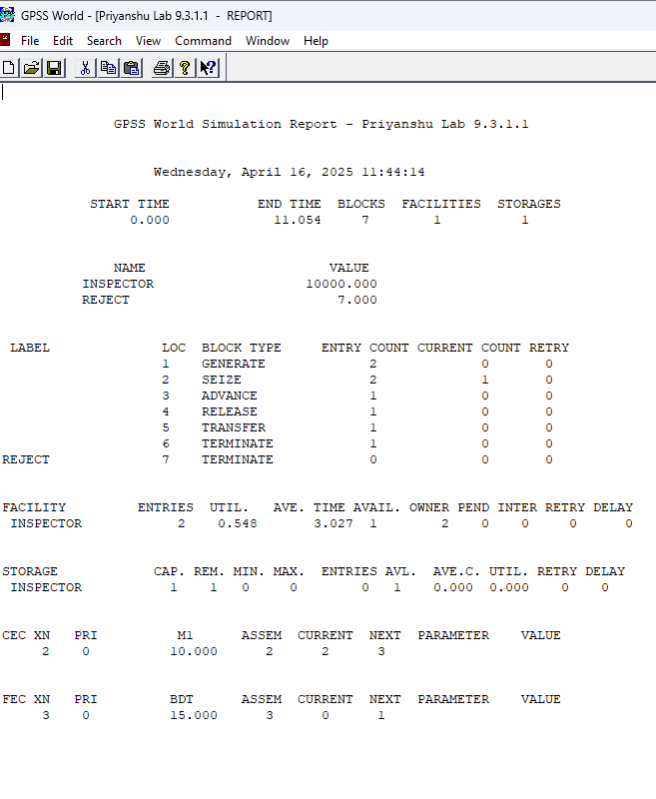

Q.4. A machine tool in a manufacturing shop is turning out parts at the rate of every 5 minutes. When they are finished, the parts are sent to an inspector, who takes 4±3 minutes to examine each one and rejects 15% of the parts. Write a GPSS program to simulate using the concept of facility.
Source code:
GENERATE 5,,,1000
SEIZE INSPECTOR
ADVANCE 4,3
RELEASE INSPECTOR
TRANSFER .15, REJECT
TERMINATE 1
REJECT TERMINATE 1
INSPECTOR STORAGE 1
START 0

Output:
